Insert your name, centre number and candidate number into the header above.
Save this evidence document as evidence_ followed by your centre number_ candidate number. For example: evidence_ zz999_9999.doc
Screenshots or program listings must be copied into appropriate cells in the following tables.
Examiners must be able to read the contents including any screenshots without the use of a magnifying glass. Answers that are not readable or missing will not be awarded any marks.
Save this evidence document at regular intervals, for example, every 10 minutes.
Question 1
Part 1(a)
{Copy and paste program code listing for question 1(a) here}

# main
Stack=[-99 for _ in range(30)]
TopOfStack=-1

Part 1(b)
{Copy and paste program code listing for question 1(b) here}
def Push(Num):
global Stack
global TopOfStack
if TopOfStack>=len(Stack)-1:
return False
Stack[TopOfStack]=Num
TopOfStack+=1
return True

Part 1(c)
{Copy and paste program code listing for question 1(c) here}
def Pop():
global Stack
global TopOfStack
if TopOfStack<0:
return -999
Num=Stack[TopOfStack]
TopOfStack-=1
return Num

Part 1(d)
{Copy and paste program code listing for question 1(d) here}

import random

# main
Stack=[-99 for _ in range(30)]
TopOfStack=-1

for i in range(40):
if not Push(random.randint(0,1000)):
print("Stack full")
break

Part 1(e)
{Copy and paste program code listing for question 1(e) here}
def FindValues():
Empty=False
count=0
while not Empty:
count+=1
Num=Pop()
if Num==-999:
print(f"The largest number that was in the stack is {Max}.\nThe smallest number that was in the stack is {Min}.")
Empty=True
if count==1:
Max=Num
Min=Num

if Num<Min: Min=Num
elif Num>Max: Max=Num

Part 1(f)(i)
{Copy and paste program code listing for question 1(f)(i) here}
import random

# main
Stack=[-99 for _ in range(30)]
TopOfStack=-1

for i in range(40):
if not Push(random.randint(0,1000)):
print("Stack full")
break

FindValues()

Part 1(f)(ii)
{Copy and paste screenshot(s) for question 1(f)(ii) here}

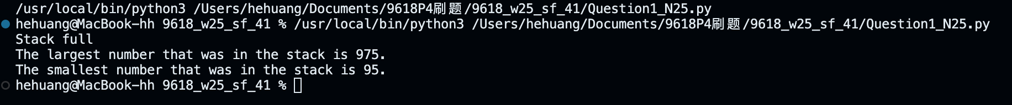

Question 2
Part 2(a)(i)
{Copy and paste program code listing for question 2(a)(i) here}

class Train:
def __init__(self,id,r):
self.__TrainIDNumber=id #PRIVATE TrainIDNumber: STRING
self.__Route=r #PRIVATE Route: INTEGER

Part 2(a)(ii)
{Copy and paste program code listing for question 2(a)(ii) here}

class Train:
def __init__(self,id,r):
self.__TrainIDNumber=id #PRIVATE TrainIDNumber: STRING
self.__Route=r #PRIVATE Route: INTEGER

def GetTrainIDNumber(self): return self.__TrainIDNumber
def GetRoute(self): return self.__Route

Part 2(b)
{Copy and paste program code listing for question 2(b) here}
#main
Tr1=Train("12ADV",134)
Tr2=Train("33ART",20)
Tr3=Train("9FKF",3)
Tr4=Train("21VBC",24)

Part 2(c)(i)
{Copy and paste program code listing for question 2(c)(i) here}

class Station:
def __init__(self,sid,np):
self.__StationID=sid #PRIVATE StationID: STRING
self.__NumberPlatforms=np #PRIVATE NumberPlatforms: INTEGER
self.__Trains=[] #PRIVATE Trains: ARRAY[0:9] OF Train
self.__NumberTrains=0 #PRIVATE NumberTrains: INTEGER

Part 2(c)(ii)
{Copy and paste program code listing for question 2(c)(ii) here}

class Station:
def __init__(self,sid,np):
self.__StationID=sid #PRIVATE StationID: STRING
self.__NumberPlatforms=np #PRIVATE NumberPlatforms: INTEGER
self.__Trains=[] #PRIVATE Trains: ARRAY[0:9] OF Train
self.__NumberTrains=0 #PRIVATE NumberTrains: INTEGER

def AddTrain(self,Tr):
if self.__NumberPlatforms<self.__NumberTrains+1:
return False
self.__NumberTrains+=1
self.__Trains.append(Tr)

return True

Part 2(c)(iii)
{Copy and paste program code listing for question 2(c)(iii) here}

class Station:
def __init__(self,sid,np):
self.__StationID=sid #PRIVATE StationID: STRING
self.__NumberPlatforms=np #PRIVATE NumberPlatforms: INTEGER
self.__Trains=[] #PRIVATE Trains: ARRAY[0:9] OF Train
self.__NumberTrains=0 #PRIVATE NumberTrains: INTEGER

def AddTrain(self,Tr):
if self.__NumberPlatforms<self.__NumberTrains+1:
return False
self.__NumberTrains+=1
self.__Trains.append(Tr)

return True

def GetTrains(self):
if self.__NumberTrains==0:
return "There are no trains"
temp="The trains at station "+self.__StationID+" are:\n"
for i in range(self.__NumberTrains):
temp+=(self.__Trains[i].GetTrainIDNumber()+" on the route number "+str(self.__Trains[i].GetRoute())+'\n')

return temp

Part 2(d)(i)
{Copy and paste program code listing for question 2(d)(i) here}

#main
Tr1=Train("12ADV",134)
Tr2=Train("33ART",20)
Tr3=Train("9FKF",3)
Tr4=Train("21VBC",24)

St1=Station("STH",2)
St2=Station("NTH",1)

Part 2(d)(ii)
{Copy and paste program code listing for question 2(d)(ii) here}

#main
Tr1=Train("12ADV",134)
Tr2=Train("33ART",20)
Tr3=Train("9FKF",3)
Tr4=Train("21VBC",24)

St1=Station("STH",2)
St2=Station("NTH",1)

if not St1.AddTrain(Tr1): print("Station is full")
if not St1.AddTrain(Tr2): print("Station is full")
if not St1.AddTrain(Tr3): print("Station is full")
if not St2.AddTrain(Tr4): print("Station is full")

print(St1.GetTrains())
print(St2.GetTrains())

Part 2(d)(iii)
{Copy and paste screenshot(s) for question 2(d)(iii) here}

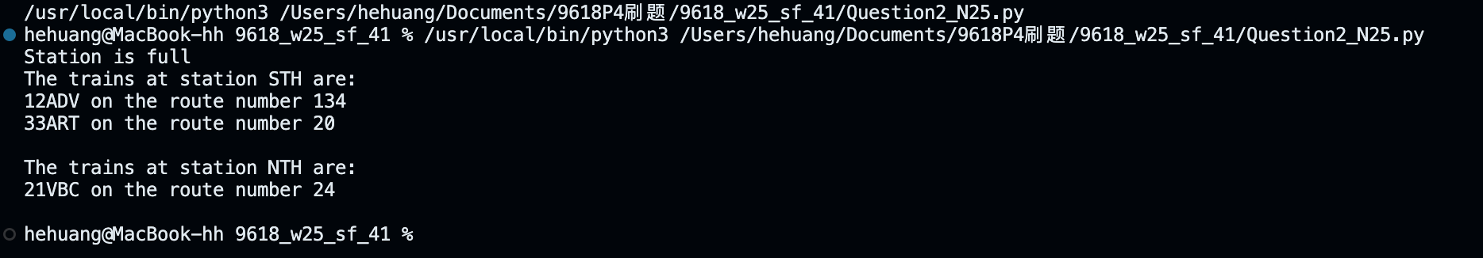

Question 3
Part 3(a)
{Copy and paste program code listing for question 3(a) here}

class Record:
def __init__(self,k,d):
self.Key=k
self.Data=d

Part 3(b)
{Copy and paste program code listing for question 3(b) here}

def InitialiseHashTable():
global HashTable
for x in range(len(HashTable)):
for y in range(len(HashTable[x])):
HashTable[x][y]=Record(-1,"")

#main
HashTable=[[None for _ in range(10)] for _ in range(100)]

Part 3(c)
{Copy and paste program code listing for question 3(c) here}

def Hash(Key):
return Key%100

Part 3(d)
{Copy and paste program code listing for question 3(d) here}

def InsertData(Rec):
global HashTable
Position=Hash(Rec.Key)
for i in range(len(HashTable[Position])):
if HashTable[Position][i].Key==-1:
HashTable[Position][i]=Rec
break

Part 3(e)
{Copy and paste program code listing for question 3(e) here}

def ReadData():
fr=open("HashTableData.txt",'r')
x=fr.readline()

while x !="":
DataRead=x.split(',')
Key1=int(DataRead[0].strip())
Data1=DataRead[1].strip()
InsertData(Record(Key1,Data1))
x=fr.readline()

fr.close()

Part 3(f)
{Copy and paste program code listing for question 3(f) here}

def GetRecord(Key):
Location=Hash(Key)
for i in range(len(HashTable[Location])):
if HashTable[Location][i].Key==Key:
return HashTable[Location][i].Data

return "Not found"

Part 3(g)(i)
{Copy and paste program code listing for question 3(g)(i) here}

#main
HashTable=[[None for _ in range(10)] for _ in range(100)]

InitialiseHashTable()
ReadData()

for i in range(5):
KeyValue=int(input("Enter the key field value. "))
print(GetRecord(KeyValue))

Part 3(g)(ii)
{Copy and paste screenshot(s) for question 3(g)(ii) here}

